Downloading Office from Office 365
Go to your MCC email
Click on the squares on the banner across the top of the page.

Then click on Office 365.
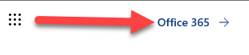
Then click on Install Office on the right side of the page.
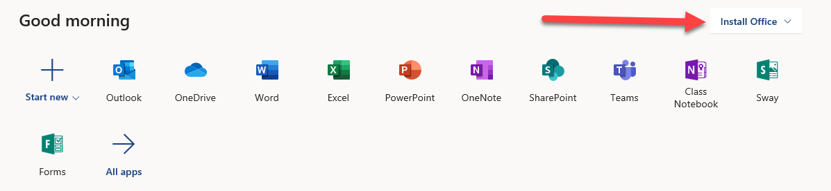

Click on Office 365 apps.
