HEALTHY RELATIONSHIPS
Increasing wellness and preventing violence
WHY HEALTHY RELATIONSHIPS ARE IMPORTANT
• Less stress
• Increased health and healing
• Greater sense of purpose
• Longer life
• Positive modeling for others
• Violence prevention

INDICATORS OF A HEALTHY RELATIONSHIP
- Mutual respect
- Understanding
- Assertive and open communication
- Trust and honesty
- Fighting fairly and controlling anger
- Problem solving and compromise
- Partners take responsibility for their own happiness, know and enforce their own boundaries, feel confident in themselves independent of the relationship, maintain their individuality
INDICATORS OF AN UNHEALTHY RELATIONSHIP
- Imbalance or dependence
- Disrespect
- Dishonesty and suspicion
- Hostility
- Intimidation and violence
- Rigidity
- Controlling behaviors
- #That'sNotLove: https://www.voutube.com/watch?v=4JYvHa03x-U
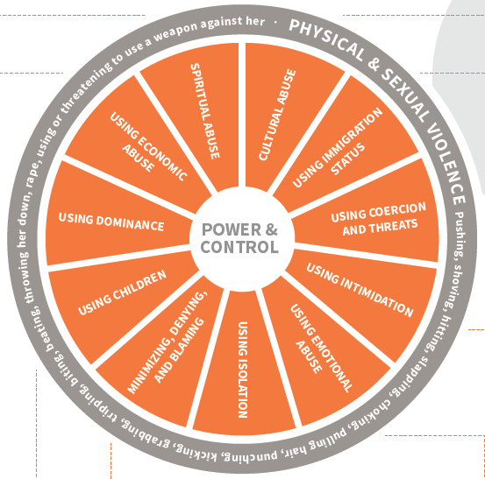
The
Power and Control Wheel. Center of wheel has the words: “power & control”, there are several different spokes circling the center that are examples of different sets of behaviors that one uses to maintain their power & control; these spokes or behaviors are: “Cultural Abuse, Using Immigration Status, Using Coercion and Threats, Using Intimidation, Using Emotional Abuse, Using Isolation, Minimizing, Denying, and Blaming, Using Children, Using Dominance, Using Economic Abuse, and Spiritual Abuse” The outer rim of the wheel represents physical, visible and threatening violence. The words around the outer rim of the wheel are: “Physical & Sexual Violence; pusing, shoving, hitting, slapping, choking, pulling hair, punching, kicking, grabbing, tripping, biting, beating, throwing her down, rape, using or threatening to use a weapon against her.”
Power
and
Control
Wheel

Power & Control on Social Media
1 – Doxxing: Finding and sharing personal information of location, family and work, and brigading: using followers to target/attack someone.
2 – Harmful Language: Hate speech, destructive language, policing language and culture.
3 – Surveillance: Using geolocations, manipulating boundaries, being blocked and refollowing, informing a blocker you are refollowing them.
4 – Kyriarchy: Denying, minimizing, forced empathy, using marginalized status to justify abuse, respectability politics, and blaming.
5 – Isolation: Encouraging massive unfollowing, ‘reporting’ people/accounts, misgendering trans and GNC people, misinformation/falsifying narratives to change how others see someone, and attempts to remove from chosen community.
6 – Using Intimidation: Creating and sending gore messages, violent images, and threats of outing/doxxing intentional misinformation, gossip, defamation, and misusing archives.
7 – Sexual Coercion & Harassment: Sexting, meme’s about someone, unwanted sexual contact, sexually explicit gore messages, and revenge porn.
8 – Gaslighting: Making target question their reality, sub-tweeting, and belief people don’t respond to abuse.
CONSENT
- When one person gives another person permission to do something.
- A hallmark of a healthy relationship, whether the relationship is long term or only for a few hours
- Partners who pressure you or guilt you into doing things, make you feel that you "owe" them, punish you for saying no, or ignore your wishes do not respect consent
- Sex without consent is sexual assault

CONSENT
- Consent is a clear and enthusiastic "yes!"
■ Dressing sexy is not consent
■ Accepting a drink is not consent
■ Dancing is not consent
■ Flirting is not consent
■ Accepting a ride home is not consent
■ Silence is not consent
■ Saying yes while drunk or high is not consent
■ Saying yes because you are scared to say no is not consent
■ Saying yes to one thing is not consent for anything else
■ Saying yes when you're younger than 16 (in NE) is not consent
- Consent is Everything: https://www.voutube.com/watch?v=OhrsmBzlStk
CREATING HEALTHY RELATIONSHIPS
- Speak up: be honest and open
- Respect each other and each other's privacy
- Set, maintain, and respect boundaries
- Maintain friendships and connections with family members
- Keep alcohol and drug use in check
- Trust your instincts, especially with a person you don't know well
- Take care of yourself

HELPING THOSE AROUND YOU
- Ask if they feel safe or would like to talk about it
- Listen, support, and withhold judgment
- Help your friend recognize that the relationship is unhealthy
- Share your belief that everyone deserves a healthy relationship
- Offer a ride or your phone for a call if a friend needs help accessing resources
- Don't contact their partner or post negative things online

LEARN MORE
- At MCC:
- Advocacy Counselors
- Title IX Coordinator
- Confidential Advocate
- College Police

- In the community:
- Women's Center for Advancement
- City Police

- Online:
- loveisrespect.org

